Day-5 Classes, Objects & Method

**Assignment**

1. To create a class, use the keyword?  
   A. new  
   B. except   
   C. class  
   D. object

**Answer:** C. class

1. A class is a blueprint of an
2. Object
3. Inheritance
4. Constructor
5. Properties

**Answer:** A. Object

1. Which is true here
2. A class is an instance of an object
3. An object is an instance of a class
4. Without class object can be made
5. Object has no instance

**Answer:** B.

1. Which is generally used for instantiating an object is called
2. Inheritance
3. Polymorphism
4. Constructors
5. Method

**Answer:** C. Constructors

1. Create a placeholder for future code we use
2. Def
3. Init
4. pass
5. def

**Answer:** C. pass

1. Which syntax is correct here to define class

A: class student:

roll= ""

gpa = ""

B: class student ()

roll= ""

gpa = ""

C: Class student:

roll= ""

gpa = ""

D: class student():

roll= ""

gpa = ""

**Answer:** A.

7. Parent class is also called?

A. derived class  
B. Child class  
C. Hybrid class  
D. base class

**Answer:** D.

8. Child class is the class that inherits from another class, also called

A. derived class  
B. Child class  
C. Hybrid class  
D. base class

**Answer:** A.

1. Which one is correct

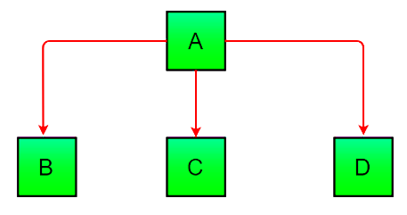

1. Muli-level
2. Multiple
3. Hierarchical
4. Single

**Answer:** C

1. Which inheritance is represented by following code

class A:

def display1(self):

print("This is class A")

class B:

def display2(self):

print("This is class B")

class C(A, B):

def display3(self):

print("This is class C")

1. Muli-level
2. Multiple
3. Hierarchical
4. Single

**Answer:** B. Multiple